## Todo: to record all of the following “transcripts”

# Part 1) History of news ( channels to get a news)

## 1st row: Evolution of news (history of news)

## Stop mp3: Lexical resource

* 手拉手地前进, **携手前进**； **紧密联系,息息相关** **[ A and B go hand in hand ]**  
  e.g. Technology and business strategy **go hand in hand.**  技术和企业战略**携手前进**e.g. Your body health and career closely **go hand in hand.**
* 分辨率; 下决心(要非常努力的做xxx)；(在会议上通过投票得出的正式的)决议；(问题，困难的)**最终**解决 resolution /ˌrɛzəˈluːʃən/

1. A resolution is a **formal decision** made at a meeting **by means of a vote.** (在会议上通过投票得出的正式的)决议 **[两项 重大决议 two major resolutions ]**e.g. He replied that the UN had passed two **major resolutions** calling for a complete military withdrawal from Afghanistan. 已经通过要求完全撤军的 两项 **重大决议**。

2. If you **make a resolution**, you decide to try very hard to do something. 下决心(要非常努力的做xxx)　**[ make a firm resolution; make a hard resolution ]** e.g. They **made a hard resolution** to lose all the weight gained during the Christmas holidays. 他们**下了一个决心要**减掉全部体重。   
=>N-UNCOUNT **Resolution** is determination to do something or not do something. 决心 **[ new year’s resolution 新年愿望/决心 ]** e.g. "I think I'll try a hypnotist[**'hipnətist**] 催眠师," I said **with sudden resolution/emphatically**. 我突然**坚决地**说。

4. resolve => resolution: t**he resolution of a problem or difficulty** is the **final** solving of it. (问题，困难的)最终解决 V.S. xx事情的解决(n) **settlement** of sth e.g. ..the successful **resolution of a dispute** involving UN inspectors in Baghdad. …对涉及联合国驻巴格达调查员的一项争议的成功解决

5. (computer science) the number of pixels per square inch on a computer-generated display; the greater the resolution, the better the picture [物] 分辨率

* soften /ˈsɒ**fən**/   
  1. E.g Soften the butter mixture in a small saucepan.  
  2. If you **soften your position**, if your position softens, you become more sympathetic and less hostile or critical. 使变温和; 变温和 e.g. The letter shows no sign that the Germans have **softened their position = relent sb’s attitude 态度已有所缓和**。 E.g. His party's policy has softened a lot in recent years. 近年来他所在政党的政策变得温和了许多。  
  3. If you **soften something** such as light, a colour, or a sound, you make it less bright, strong, or harsh. 使 (光、颜色或声音) 变柔和 **[ 柔和的颜色 soothing color ]** e.g. We wanted to soften the light without destroying the overall effect of space. 我们希望在不破坏整体空间效果的同时使光线柔和些。  
  4.  Something (like milky cream, body lotion) that **softens your skin** makes it very smooth and pleasant to touch. **使 (皮肤) 变得光滑柔软; 滋润柔滑肌肤** e.g. This **brand-new** body lotion is designed to moisturize and **soften the skin.** …为**滋润柔滑肌肤**而设计的产品。
* treacherous /ˈtrɛtʃərəs/ 背信弃义的(表不满); 非常危险的变化莫测的(天气，水流)

1. If you describe someone as **treacherous**, you mean that they are likely to betray you and cannot be trusted. **[ a treacherous person 一个背信弃义的人 ]** E.g. He publicly left the party and denounced its **treacherous leaders**. 遣责党内那些 **背信弃义的领导人们**。

2. If you say that something is treacherous, you mean that it is **very dangerous and unpredictable.** 非常 危险的变化莫测的(天气，水流) **[ treacherous weather; treacherous water current ]**   
e.g. The current of the river is fast flowing and **treacherous**. 河水的水流湍急而且**(危险)变化莫测。** e.g. Five scuba divers were missing today after they dove into **[treacherous] waters.**

* versatile /ˈvɜːsəˌtaɪl/ , **versatility vɝsə'tɪləti**

1. If you say that a person is versatile, you approve of them because they have many different skills. 多才多艺的表赞许 e.g. He had been one of the game's most versatile athletes. 他是这次运动会中最有才能的运动员之一。

2.**N-UNCOUNT 多才多艺 versatility** e.g. Aileen **stands out** for her incredible **versatility** as an actress.艾琳以其难以置信的**多才多艺**而出类拔萃。

3. A tool, machine, or material that is **versatile** can be used for many different purposes. (工具，机器）用途广泛的 e.g. Never before has computing been so versatile. 计算机技术从未像现在这样用途广泛。4.**N 用途广泛 versatility** e..g Velvet as a fabric is not known for its versatility. 天鹅绒作为一种织物并非以其***用途广泛***而闻名。

* (射鸟/动物)散弹猎枪shotgun /ˈʃɒtˌɡʌn/  A shotgun is a gun used for shooting birds and animals which fires a lot of small metal balls at one time.
* podcast /ˈpɒdˌkɑːst/:   
  A podcast is an audio file similar to a radio broadcast, that can be downloaded and listened to on a computer or iPod. 播客 e.g. Now there are thousands of **podcasts** available to download daily. 现在每天有数千个播客可供下载 e.g. Can I use your phone for a minute? I want to listen to SNT's daily news **podcast** .
* medieval times /ˌmɛdɪˈiːvəl/ :   
  Something that is medieval relates to or was made in the period of European history between the end of the Roman Empire in AD 476 and about AD 1500.中世纪的 **[a medieval castle中世纪的城堡。]**
* **town crier “号外，号外“　 (过去的)街头公告员**In former times, esp the **medieval times**, a town crier was a man whose job was to walk through the streets of a town shouting out news and official announcements.
* 印刷机**a printing press：**  
  A printing press is a machine used for printing, especially one that can print books, newspapers, or documents in large numbers. **Printing press** was invented in **medieval times**.
* **缺陷，缺点: the drawbacks/ disadvantages/ deficiency of sth**
* **负面/不好的一面：downsides V.S. (事情的)另一面: the flip side of sth**
* 随着（手机，电脑，新科技）的出现 **[ with the advent /ˈædvɛnt/ of sth; with the advent of smart phone; with the advent of computers; with the advent of intelligence ]** This all changed **with the advent /ˈædvɛnt/ of** the newspaper.
* **mass-printed** newspaper: 大量打印的报纸; **mass-produced** bicycles
* **target demographic (影视剧， 广告的) 目标受众群体)**e.g. Newspapers, were, in many ways, revolutionary革命的. Compared with the traditional **“town crier 号外”,** the newspaper reaches a huge audience and widens its **target demographic**
* Swing, swung, swung
* draconian /dreɪˈkəʊnɪən, drə-/   **draconian laws or measures** are extremely harsh and severe. 严酷的 (法令或措施) e.g ...indications that there would be no **draconian measures** to lower U.S. health care costs.…迹象表明将不会有**严厉的措施**来降低美国的医疗成本
* **burglarize v) => N) burglary = > burglar (夜贼，窃贼)** If a building is **burglarized**, a thief enters it by force and steals things, especially at night,  夜盗, 闯入…行窃
* **tiptoe /ˈtɪpˌtəʊ/**

1.V-I If you **tiptoe to some place**, you walk there very quietly without putting your heels on the floor when you walk. 踮着脚尖走 e.g. She slipped out of bed and **tiptoed to t**he window. 她溜下床，踮起脚尖走向窗户。I didn't want to make any noise, so I **tip-toed to** the phone and called the police.

2. If you **do something on tiptoe or on tiptoes**, you do it standing or walking on the front part of your foot, without putting your heels on the ground. 踮着脚 e.g. She leaned her bike against the stone wall and stood **on tiptoe** to peer over it. 然后**踮起脚**从墙头望过去

* Intoxicated: **极度兴奋的, 喝醉的, 被xxx陶醉了** [in'tɔksikeitid]

1. feel intoxicated = super excited and thrilled 极度兴奋的.
2. Someone who is intoxicated is **drunk or smashed** 喝醉的 e.g The **reckless driver** appeared **intoxicated**, police said. 好像是**喝醉**了 =>  Someone who is **smashed** is **extremely drunk. 烂醉的**
3. If you **are intoxicated by or with something** such as a feeling or an event, you are so excited by it that you find it hard to think clearly and sensibly. 被xxx陶醉了   
   e.g. My cousins seem to have **become intoxicated by** their success. 被他们的成功陶醉了 => **heady, headier, headiest:** A **[ heady drink:令人醉的饮品； 令人陶醉的气氛/音乐： heady atmosphere/music/vibe/ experience]** strongly affects your senses, for example, by making you feel so drunk or excited that that you find it hard to think clearly, **rationally, or sensibly** 令人陶醉的 e.g..in the **heady honeymoon days** just after their marriage. …婚后令人陶醉的日子里

* 喝醉的: intoxicated = drunk; => **烂醉的 smashed=** extremely drunk or intoxicated.

## Video: how to get a news

How do you get a news? Do you watch it on TV or listen to it on the radio? Do you read online newspapers or news blogs from pop social apps? Or do you get a **podcast** delivered to your email box?

News have never before been available to so many people in so many different forms, and so convenient, so immediate. However, getting the news didn’t always use to be so easy.

“Oyez, Oyez”– In **medieval times**, many governments and town councils relied on a man with a loud voice to deliver news to the general public. This person was called the “**town crier”.** The English **town crier** would call out “Oyez, Oyez”, which doesn’t actually mean “yes”, but **derives from** the Norman word for “here comes a news. Listen, Listen”.

Of course, this method of delivering the news had its **drawbacks/down sides/disadvantages/deficiency缺陷，缺点；缺乏.** This main **deficiency** is that it was lacking a wide audience. Furthermore/moreover, the information delivered was **strictly/draconianly** controlled by the local council or government. This all changed **with the advent /ˈædvɛnt/ of** the newspaper.

Around the beginning of the 17th century, the first mass-printed newspaper appeared in northern European countries such as Germany and Holland. Newspapers, were, in many ways, **revolutionary**革命的. Compared with the traditional “**town crier” “号外，号外“**, the newspaper reach a huge audience and widen its **target demographic (目标受众群体**). They could be written and printed by anyone, as long as they had access to **a printing press 印刷机** and enough money to fund the publication. **In stark contrast to** 与……形成鲜明的对比 the **“town crier”,** they didn’t necessarily have to do was reflect the government opinion **in this day and age. In other words, to some extent**, newspaper with freedom of thought and speech, opinion and expression **went hand in hand(紧密联系息息相关).**

**Leap forward 跃进；向前跳；快速发展** to the 20th century, and the newspaper sales have fallen **drastically/rapidly.** The reason? **The advent /ˈædvɛnt/ of** television. In some ways, television has much more in common with the “town crier” than it does with newspapers. News reports are shorter, more visual, and delivered orally rather than via **the printed word**. Furthermore/moreover, in most countries, television news channels are controlled by a small handful powerful people. In a sense, they tell us what to believe. Think about it.















Swing, swung, swung



## Dialogue

LINDA: Can I use your phone for a minute? I want to listen to SNT's daily news **podcast** .

RON: Yeah, just a sec. Let me just finish clearing out my email inbox . OK. **Here you go**.

LINDA: Thanks. These **podcasts** are so cool. You ever listen to them? I mean, think about it: anyone in the world with internet and a device can listen to news from any country. They reach a much **wider audience** than even a **mass-printed newspaper**.

RON: Ha! Yeah, and compare that to **medieval times**. Just imagine the local **town crier** （号外号外） shouting out the news in a little village.

## Reading a blog in CNN

Last night, I witnessed a break-in! I was fast asleep when I was woken up by this loud **bang/loud noise** outside. When I got to the window, I saw a dark, shady-looking figure **yanking猛的一拉** open my neighbor's basement window. Man, was I scared! I didn't want to make any noise, so I **tip-toed** to the phone and called the police. They arrived within minutes, surrounded the house and **shone a huge searchlight** into my neighbor's garden. Well, I can't tell you how surprised I was when I saw who the '**burglar'** was. Out of the dark he came, stumbling and with a puzzled look on his face: my neighbor! It appeared he was completely smashed. He'd lost his keys and had tried to get into his house through his window. He was a little embarrassed the next day but, to be honest, I was relieved.  
______________________________________________________  
  
**The Daily Star**

Last night, a courageous **有胆量的，勇敢的** citizen called the police in order to prevent a crime. Mr. Constable called the police at 2 a.m. because he heard a loud noise coming from his neighbor's house. He immediately raised the alarm. When the police arrived, they encountered the slightly puzzled and highly **intoxicated/drunk /smashed** Mr. Wagner, Mr. Constable's neighbor, who had lost his keys and was trying to enter his own home. Nobody was arrested and no charges were pressed. **//smashed = extremely drunk or extremely intoxicated 烂醉的**

## Stop mp3: 2nd row Narrative structure (of telling a story/news)

When people report the news in personal blogs, they usually follow the same structure used to tell a story: narrative structure, that is the sequence of plots in a story. The stages of narrative structure include the following sections:

1. **introduction**
2. **rising action** (the story becomes intense, attractive, and eye-catching),
3. **climax** (the story/news **plot情节** reaches the peak.),
4. **falling action** ( the plot slows down)
5. **resolution** ( (问题，困难的)最终解决; 决心/决议; ).

|  |  |
| --- | --- |
| The **introduction** presents characters in a situation or conflict that develops with increasing suspense. Here's a sample introduction from someone telling personal news: | |
|  | |
|  |  |

|  |  |
| --- | --- |
|  | *I was walking down the street to get some groceries when I saw a pregnant woman with three children.* |

|  |  |
| --- | --- |
| The **introduction** flows into **rising action**, a stage where the events become more intense and the conflict grows. As the **rising action** reaches a peak, the **climax**, or turning point, is delivered. | |
|  | |
|  |  |

|  |  |
| --- | --- |
|  | *Suddenly the woman stood still, eyes wide open, grabbing her belly. She was having her baby! I ran over to her and helped her and her children into the neighbor's house. She somehow lay down on the floor, and began the intense and incredible process of delivering a baby.* |

|  |  |
| --- | --- |
| The action slows after the **climax** into **falling action**, a stage where the conflict is extended. | |
|  | |
|  |  |

|  |  |
| --- | --- |
|  | *The mother's screams grew. At the same time, the neighbor was shouting into her cell phone for a doctor. The house seemed to shake with their fear. Minutes later, the air in the house was still.* |

|  |  |
| --- | --- |
| Finally, **falling action** softens[**'sɔfn**] into the **resolution**, a stage where issues are resolved and the characters continue on, changed, into their new life. | |
|  | |
|  |  |

|  |  |
| --- | --- |
|  | *I was looking down at a stranger, exhausted and crying, holding her new, healthy baby girl in her arms. Until that walk to get some groceries, I never truly realized what a wonder childbirth is.* |

## Stop mp3: Narrative structure

1. Introduction
2. Rising action
3. Climax
4. Falling action
5. resolution

## 3rd row Guess meaning from context

It's time-consuming and inefficient to look up every word you don't know in a dictionary. Instead, try to work out the meaning of words using the other words around them. Work out the words in **brackets [ ]** in the following sentences.

## Stop mp3: 4th row

# Part 2) Newspaper headline (A **short punchy headline**强力的 in a new)

## 1st row

## Stop mp3: Lexical resource

* coincidence /kəʊˈɪnsɪdəns/   A coincidence is when two or more similar or related events occur at the same time by chance and without any planning or **beforehand**提前的 notification. 巧合 **[ what a coincidence! What such as coincidence! ]**

e.g. Mr. Berry said the timing was a coincidence and that his decision was unrelated to Mr. Roman's depature. 贝里先生说时间的安排是个巧合 e.g. My best friend and I got the offer from the same **prestigious university** 有声望的in ivy league. What such a coincidence!

* **Misplaced/ dangling modifier** 放错位置的修饰词 is a word or phrase apparently modifying an unintended word because of its improper placement in a sentence.

**Modifiers:** are words or phrases that describe something or add **some complements补足**. Modifiers should be placed as close as possible to the thing that they describe, otherwise, they can lead to confusion.

* **colloquial** /kəˈləʊkwɪəl/, **colloquially** [kə'lokwɪəli], colloquialism /kəˈ**ləʊkwɪəˌlɪzəm**/  
  Colloquial words and phrases are informal and are used mainly in conversation or oral speaking 口语的 **[ a colloquial expression 一个口语表达法; colloquial language ] =>** A **colloquialism**/kəˈləʊkwɪəˌlɪzəm/ is a colloquial word or phrase. 口语; 白话
* xxx的化身/象征 embodiment of **sth [ 自由的化身/象征 embodiment of freedom; 民主的化身/象征 embodiment of democracy ]** e .g. "Liu Xiaobo, the Noble Peace Award winner, was the true **embodiment of the democratic, non-violent ideals** he so **ardently(深深的，热忱的)** advocated" //**深深的/热忱的爱 ardent love**
* trumped-up ['trʌmp**t'ʌp**]  **[ (指控)捏造的 trumped-up charges; trumped-up accusation ]**Trumped-up charges/accusations are untrue, and made up in order to **set sb. up/ frame sb 陷害**; and push sb. into prison unfairly. E.g. Liu's wife, Liu Xia has been under **house arrest 软禁** since Liu's Nobel victory. With her communication with the outside world almost completely cut off by the government, Liu Xia has been suffering severe depression, according to friends, especially after authorities sentenced her brother to 11 years in prison over what supporters call **trumped-up**['trʌmp**t'ʌp**]  **charges /accusation** of **business fraud/scam/shenanigan.**
* **bogus account/fake account / ˈbəʊɡəs/** If you describe something as bogus, you mean that it is not genuine. 伪造的 [ their bogus insurance claim.他们伪造的保险索赔; bogus account ] e.g Well’s Fargo created thousands of bogus accounts in order to fraudulently boost their sales target.
* **为xxx奉献了一生； 倾其一生做xxx: dedicate one’s life to sth; dedication;**   
  e.g. US Secretary of State said Liu "**dedicated his life to t**he betterment of his country and humankind, and to the pursuit of justice and liberty," and urged Chinese authorities to release Liu's wife from **house arrest 软禁** and allow her to travel outside China
* **和sb有不同的 想法/立场at odds with sb** = have different, even opposite opinion or stance from sb   
  e.g. Liu was first jailed for his role in the 1989 pro-democracy movement after the bloody crackdown in Beijing's Tiananmen Square -- and later for **petitioning for 请愿** political reform and co-writing a paper on policy toward Taiwan that was **at odds with** the government stance.
* **sensation /sɛnˈseɪʃən/**    
  1. A sensation is a physical feeling. (身体的)感觉 [ **愉快的感觉: pleasant sensation; 有趣的感觉 interesting sensation ]**   
  e.g. Floating can be a very **pleasant sensation**. 漂浮会给人一种非常**愉快的感觉**。  
  E.g. Sky diving, well, can be an amazingly **interesting sensation.**  
  2. Sensation is your ability to feel things physically, especially through your sense of touch. （身体的）感觉能力e.g. The pain was so bad that she lost all sensation. 疼得太厉害了，她失去了感觉能力。  
  3. You can use sensation to refer to the general feeling or impression caused by a particular experience. (某种经历所产生的) 整体感觉 e.g. It's a funny sensation to know someone's talking about you in a language you don't understand. 知道有人正用一种你不懂的语言谈论你，这种感觉真奇怪。  
  4. If a person, event, or situation is a **sensation**, it causes great excitement or interest. 引起轰动的人或事物 **[ an IT sensation 一个IT轰动; 引起轰动 cause a sensation ]**   
  eg. ...the film that turned her into **an overnight sensation**. …让她**一夜成名**的影片。  
  e.g. She was just 14 when she **caused a sensation** at the Montreal Olympics. 她在蒙特利尔奥运会上引起轰动时   
  e.g. Well, drone, it **causes such a sensation** in air industry 无人机是航天行业的一个轰动
* sensationalized
* 八卦，花边新闻的）小报 tabloid /ˈtæblɔɪd/  A tabloid is a newspaper that has small pages, short articles, and a lot of photographs. Tabloids are usually considered to be less serious than other newspapers, compared with **broadsheet** . e.g. The **tabloids** speculated as to whether Zhaoliying (one of the most **sought-after actresses最吃香的演员** in CHINA) was having an affair, and with whom. 那些通俗小报猜测她是否正有风流韵事，以及跟谁有   
  => V.S. tablet: 碑 ( **clay tablet**)；药片pill；写字板；平板电脑
* 文盲的Illiterate /ɪˈlɪtərɪt/ , literate => sb. who is illiterate does not know how to read or write.
* What strategy can be used for a news headline to grab attention of audience?
  + **押头韵al**literation  /əˌlɪtəˈreɪʃən/ (illiterate): alliteration /əˌlɪtəˈreɪʃən/ use of the same **consonant**/ˈkɒnsənənt/ 辅音 at the beginning of each stressed syllable in a line of verse;   Alliteration is the use in speech or writing of several words close together that all **begin with the same letter or sound. 押头韵** e.g. **A**ngry **A**nts **A**ttack **A**ngela!
  + assonance /ˈæsənəns/ 类似的音韵; 半谐音： the use of the same vowel sound元音 with different **consonants** **/ˈkɒnsənənt/** or the same consonant with different vowels in successive words or stressed syllables, as in a line of verse.   
    Examples： time and light or mys**tery** and ma**stery**

**In a nutshell,** headline writers also use **alliteration**, the repetition of consonant ['kɔnsənənt] sounds, and **assonance** /ˈæsənəns/, the repetition of vowel sounds, in order to **grab attention of audiences.**

* 辅音 consonant /ˈkɒnsənənt/  V.S. .元音 vowel
  + A **consonant**/ˈkɒnsənənt/ is a sound such as "p," "f," or "t" which you pronounce by stopping the air flowing freely through your mouth. 辅音
  + vowel /ˈvaʊəl/ : you pronounce with your mouth open, allowing the air to flow through it. 元音 e.g. The vowel in words like "my" and "thigh" is not very difficult.  
    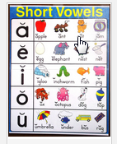

## Stop mp3: Formats of news media

* tabloid: smaller page with huge headlines; sensational articles (轰动性的文章)  
   V.S. 
* Broadsheet: (通常比其他报纸严肃的) 大幅报纸  
  A broadsheet is a newspaper that is printed on **large** sheets of paper. Broadsheets are generally considered to be more serious than other newspapers. e.g. Even the broadsheets made it their lead story. 就连大幅报纸都把它作为头条新闻报道

## Stop mp3: Tabloid newspaper V.S. broadsheet , Comparison by using Venn diagram

|  |  |  |
| --- | --- | --- |
| Properties/elements of object | Object (tabloid) | Object (broadsheet) |
| Page size | Small | Large sheet of paper |
| Style of headline (reflects the report underneath)  // A **short punchy headline**强力的 in a new | Huge headline (all capital letters)  e.g. **~~A~~** GOSSIPAL GIRLS MARRIED WITH A FOOTBALL STAR | Normal headline (a full sentence with neutral style)  e.g. ~~The~~ Drone Is Missing After The Pilot Mis-Operate It! |
| Content of the newspaper | Short, **sensational** article轰动 (花边新闻, not forma) | * Long, denser article * Represent only the fact |
|  |  | Broadsheets are generally considered to be more serious than other newspapers. |
|  |  |  |
|  |  |  |
|  |  |  |

## Video











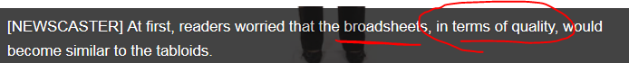

 (让他们松口气)



 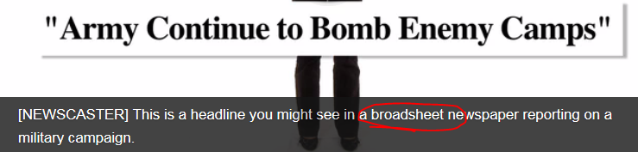

Notice, first of all, not all letters are capitals. The whole sentence is in title case. This makes the tone more serious than tabloid.

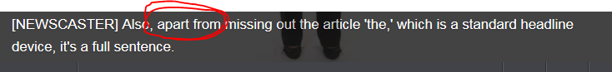



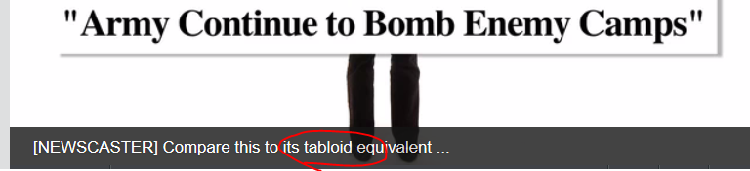





**colloquial /kəˈləʊkwɪəl/, colloquially [kə'lokwɪəli], colloquialism /kəˈləʊkwɪəˌlɪzəm/**

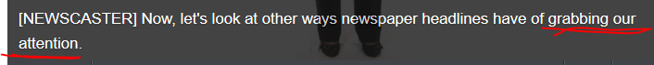

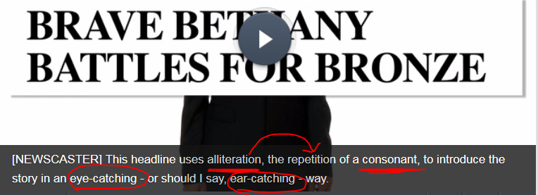

* What strategy can be used for a news headline to grab attention of audience?
  + **押头韵al**literation  /əˌlɪtəˈreɪʃən/ (illiterate): alliteration /əˌlɪtəˈreɪʃən/ use of the same **consonant**/ˈkɒnsənənt/ 辅音 at the beginning of each stressed syllable in a line of verse;   Alliteration is the use in speech or writing of several words close together that all **begin with the same letter or sound. 押头韵** e.g. **A**ngry **A**nts **A**ttack **A**ngela!
  + assonance /ˈæsənəns/ 类似的音韵; 半谐音： the use of the same vowel sound元音 with different **consonants** **/ˈkɒnsənənt/** or the same consonant with different vowels in successive words or stressed syllables, as in a line of verse.   
    Examples： time and light or mys**tery** and ma**stery**

**In a nutshell,** headline writers also use **alliteration**, the repetition of consonant ['kɔnsənənt] sounds, and **assonance** /ˈæsənəns/, the repetition of vowel sounds, in order to **grab attention of audiences.**





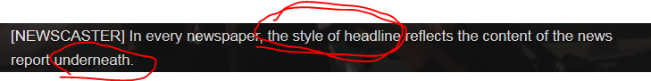

















## Stop mp3: Ground rules for writing a headline

**Newspaper headlines follow fairly strict stylistic conventions**. Read the headlines and decide which convention they are an example of. What is core, must use a **short punchy headline**强力的 in a new.

Newspaper headlines, **short and punch**强力的, in a new should **grab attention**, be easy to read and fit in a small space.

Two techniques for writing them are:

* **keep it short and punchy**强力的, and
* **don't use articles** (like **a** or **the**).
* **Tips: can use alliteration or assonance to grab audiences’ attention (e.g. Angry Ants Attack Angela! )**

## Alliteration or assonance in a headline

 What strategy can be used for a news headline to grab attention of audience?

* + **押头韵al**literation  /əˌlɪtəˈreɪʃən/ (illiterate): use of the same **consonant**/ˈkɒnsənənt/ 辅音 at the beginning of each stressed syllable in a line of verse;   Alliteration is the use in speech or writing of several words close together that all **begin with the same letter or sound. 押头韵**e.g. **A**ngry **A**nts **A**ttack **A**ngela! //all “A”s, alliteration  
    e.g. **D**entist **d**enied **d**oing **d**amage. //all “D”s, alliteration
  + assonance /ˈæsənəns/ 类似的音韵; 半谐音： the use of the same vowel sound元音 with different **consonants** **/ˈkɒnsənənt/** or the same consonant with different vowels in successive words or stressed syllables, as in a line of verse.   
    Examples： time and light or mys**tery** and ma**stery**  //stery: 类似的音韵 assonance  
    e.g. Fall**en** firefighters forgott**en**  //en: 类似的音韵 assonance  
    e.g. Seniors celebrate old**en** gold**en** days //en: 类似的音韵 assonance

**In a nutshell,** headline writers also use **alliteration**, the repetition of consonant ['kɔnsənənt] sounds, and **assonance** /ˈæsənəns/, the repetition of vowel sounds, in order to **grab attention of audiences.**

## Question style headine

|  |  |  |
| --- | --- | --- |
| Headlines also **ask questions** or provide the reader with a **how-to**. | | |
| e.g. What is the **fallout from Brexit**?  **//radioactive fallout; the fallout from sth = the bad or negative consequences of sth** |  |  |

Newspaper headlines follow fairly strict stylistic conventions. Read the headlines and decide which convention they are an example of. The key is that “A **short punchy headline**强力的 in a new”.

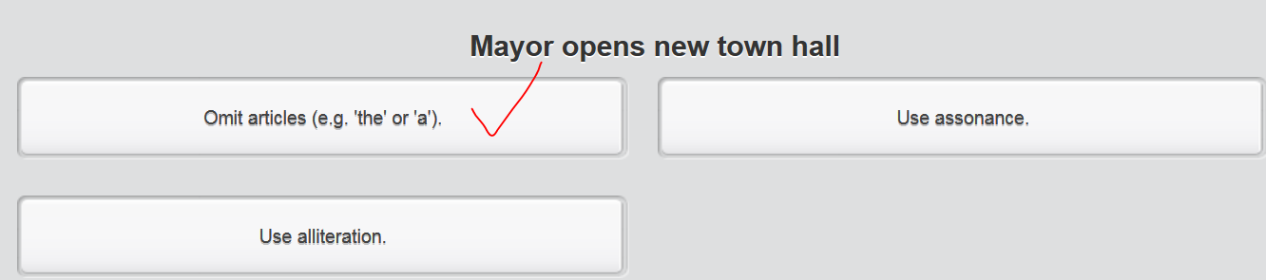



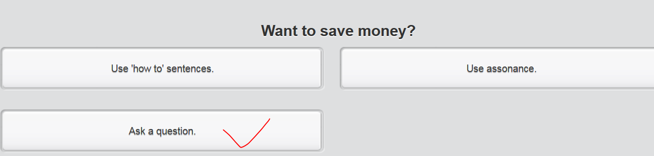





## 2nd row) Misplaced/dangling modifiers

## Stop mp3: Misplaced/dangling modifiers

|  |
| --- |
| **Misplaced/ dangling modifier** is a word or phrase apparently modifying an **unintended/unexpected** word because of its **improper** placement in a sentence.  Modifiers are words or phrases that describe something. Modifiers should be placed as close as possible to the thing they describe, or they can lead to confusion. Notice the difference in meaning between the first sentence and the second. |
| Although (the expert is) nearly dead, the experts tried to save the tree. |
| V.S. |
| Although the tree was nearly dead, the experts tried to save it. |
|  |
| In the first sentence, **Although nearly dead** is next to **the experts**, so we believe that it is the experts who are nearly dead. In the second, we know that it's the tree that's nearly dead. |
| Here is another example of a misplaced/dangling modifier. |
|  |
| He gave food to the horse **that had been slightly heated. //misplaced/dangling modifier** |
|  |
| The writer means that the food had been slightly heated, not the horse. Here is the correct version. |
|  |
| He gave food **that had been slightly heated** to the horse. |

## Stop mp3: 2nd row>3rd tab



## Stop mp3　4th row

* Don’t you love **tabloids**? It’s very **entertaining**.
* Well, and very **sensational**  炒作／轰动的
* Right, the story is always very odd and amazing, and very eye-attracting/ear-attracting. It can always quickly grab audiences’ attention. Look at this, two men picked the same **lottery** ['lɑtəri] no. at the same time, each of them won 1000 bucks.
* Wow, what such a coincidence! 太巧了了，巧合
* Here is another one. “Angry horse attacked a farmer with a stick”
* That headline definitely needs some work.
* What do you mean?
* Probably that the horse got mad, and so the farmer had to punish him.

# Part 3) Prepare a news report

## Stop review Stop mp3: Lexical resources

|  |
| --- |
| * Ready to rehearse? Let's **take it from the top (NG:** 【戏剧】从头开始；重演)   e.g. Ready? Well, let’s take it from the top, OK?   * The **WHO** said thousands have **contracted** the **disease** 染上了xxx疾病. |
| * EU ministers are trying to prevent a **pandemic**. E.g. A **pandemic** is an occurrence of a disease that affects many people over a very wide area. 流行病 |

* **善意的谎言 a white lie**If you refer to an untrue statement as **a white lie**, you mean that it is made to avoid hurting someone's feelings or to avoid trouble, and not for an evil purpose.
* discriminatory /dɪˈskrɪmɪ**nətərɪ**/  Discriminatory laws or practices are unfair because they treat one group of people worse than other groups. 歧视性的   
  e.g. These reforms will abolish/**repeal** racially discriminatory laws. **废除** 种族歧视法律
* **varnish** /ˈvɑːnɪʃ/ V.S. **vanish**= disappear

1.N) Varnish is an oily liquid that is painted onto wood or other material to give it a hard, clear, shiny surface. 清漆 e.g. This brand of varnish is a high-end decoration material, made in German.这种清漆  
2.V-T If you **varnish something,** you paint it with varnish/oily liquid. 给…涂上清漆, 使有光泽   
e.g. Varnish the table with two or three coats of water-based varnish. 给桌子涂上2到3层水性清漆   
=> varnished: 涂漆的,有光泽的  
=> unvarnished [ʌn'vɑːnɪʃt] adj. 未涂漆的；无装饰的；无掩饰的

* Political correctness  (PC) is the attitude or policy of being extremely careful not to offend or upset any group of people in society who have a disadvantage, or who have been treated differently because of their sex, race, or disability. 严格避免任何（因性别，种族，残障）　歧视的态度或政策 => 礼貌用语　 => adj **a politically correct person**
* sexist, sexism  /ˈsɛksɪst/    
  If you describe people or their behaviour as **sexist**, you mean that they are influenced by the belief that the members of one sex, usually women, are less intelligent, less smart, or less capable than those of the other sex and need not be treated equally. (尤指对女性) 性别歧视的   
  e.g. Old-fashioned **sexist** attitudes are still common. 老套的性别歧视态度仍普遍。  
  E.g. A **sexist** is someone with sexist views or behaviour. 性别歧视者 e.g. It's got nothing to do with sexism. You know I'm not a sexist. 这与性别歧视毫无关系。你知道我不是个性别歧视者
* sexism /ˈsɛksɪzəm/   
  Sexism is the belief that the members of one sex, usually women, are less intelligent or less capable than those of the other sex and need not be treated equally. It is also the behaviour which is the result of this belief. (尤其对女性的) 性别歧视
* Feminist, feminism  /ˈfɛmɪˌnɪzəm/   1. Feminism is the belief and aim that women should have the same rights, power, and opportunities as men. 女权主义, 男女平等主义 e.g . ...Barbara Johnson, that champion of radical feminism. …芭芭拉·约翰逊，激进女权主义的拥护者  
  feminist /ˈfɛmɪnɪst/: A feminist is a person who believes in and supports feminism. 女权主义者; 男女平等主义者 e.g. Only 16 percent of young women in a 1990 survey considered themselves feminists. 只有16%的年轻女性在1990年的一次调查中认为自己是女权主义者。
* Racist 种族主义者; 种族主义的 => racism

1. racist ['reisist]  If you describe people, things, or behaviour as racist, you mean that they are influenced by the belief that some people are inferior because they belong to a particular race. 种族主义的; e.g. You have to acknowledge that we live in a racist society. 在一个有种族歧视的社会。  
2. A racist is someone who is racist. 种族主义者 e.g. He has a hard core of support among white racists. 他得到了白人种族主义分子强有力的支持

* racism /ˈreɪsɪzəm/  Racism is the belief that people of some races **are inferior to** 优越于others, and the behaviour which is the result of this belief. 种族主义; 种族歧视   
  e.g.There is a feeling among some black people that the level of racism is declining. 有些黑人感觉到种族歧视的程度正在减轻

## Stop mp3: 1st row PC/political correctness

**Political correctness  (PC)** is the attitude or policy of being extremely careful not to offend or upset any group of people in society who have a disadvantage (such as visually impaired; physically impaired or hearing impaired), or who have been treated differently because of their sex, color, race, or disability. 严格避免任何（因性别，种族，残障）歧视的态度或政策 => 礼貌用语

Take me for example. I’m a politician. Now does it matter to you that I’m a man or women? Or does it matter that i’m good at job?

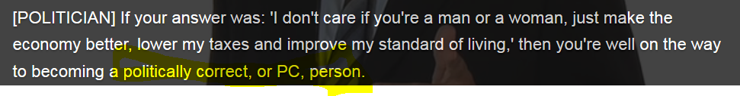

|  |  |
| --- | --- |
| **PC (political correctness) 礼貌用语** | **~~Political incorrectness~~** |
| Police officer as the PC word | ~~police~~**~~man~~** ~~or policewoman~~ |
| Post officer, postworker as the PC word | ~~Postman~~ |
| Flight attendant (FA) as the PC word | ~~Stewardess /ˈs~~**~~tjʊədɪs~~**~~/~~ |
| Homemaker | ~~Housewife~~ |
| The senior | ~~elder, old~~ |
| The visually impaired 视力损害的 | ~~blind~~ |
| The hearing impaired | ~~Deaf~~ |
| Physically impaired | ~~handicapped~~ |
| Overweight | ~~Fat~~ |
|  | |

## Video (PC word)



Instead, it’s “police officer” that is a political correctness (PC) word that doesn’t make the gender remarkable at all.

 



Why?

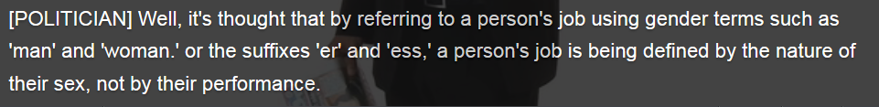

Take me for example. I’m a politician. Now does it matter to you that I’m a man or women? Or does it matter that i’m good at job?









You cannot say “fat” like that. **The politically correct (PC) word** for “fat” is “overweight”.

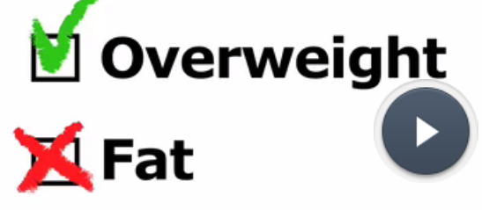





  
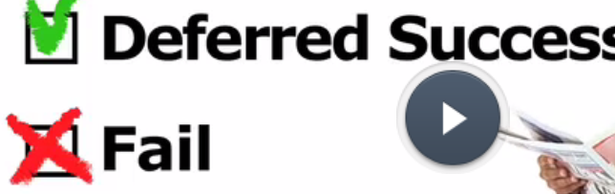





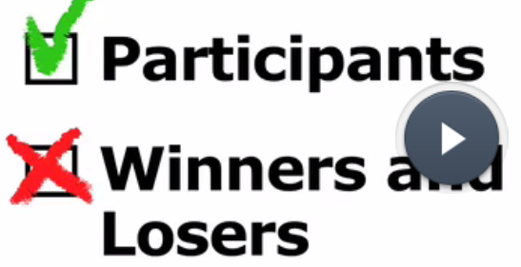



Vanish: disappear

Varnish

Unvarnish:/



## Stop mp3: 2nd row news-related dictionary

This **video footage** should heighten the **drama**.

Use a more serious **to[ne o]f voice** to report this story

Ready to rehearse? Let's **take it from the top (NG:** 【戏剧】从头开始；重演).

e.g Reporters may use words like these to report an international health crisis

|  |
| --- |
| The **WHO** said thousands have **contracted** the **disease** 染上了xxx疾病. |
| EU ministers are trying to prevent a **pandemic**. |
|  |
| Researchers are not sure how the virus spreads. |
| **Symptoms** include a headache and sore throat. |

E.G.

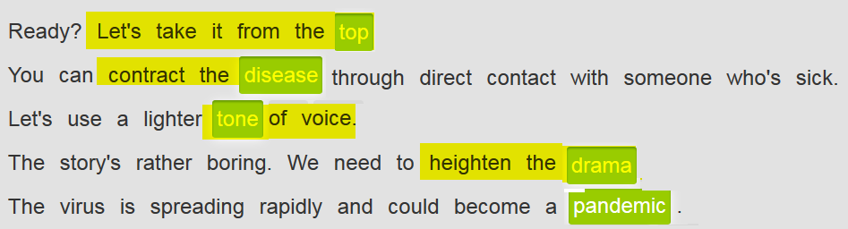

## Stop mp3: 3rd row Structure of a TV news report

|  |  |
| --- | --- |
| **Structure of a TV news report** | |
|  | |
| A TV news report often has a predictable structure. The reporter usually starts with **an opening line/remarks ( a sort of signpost** used in a public speech) that **grabs the viewer's attention**. | |
|  | |
|  |  |

|  |  |
| --- | --- |
|  | *Welcome to News Night. Our top story tonight is the Rivenian pandemic.*  *Good morning, welcome to CNN news. Here comes the breaking news today.* |

|  |  |
| --- | --- |
| Then, the reporter may **summarize the story** in what's known as the **lead**, which should answer the questions **Who, What, When, Where and Why?** | |
|  | |
|  |  |

|  |  |
| --- | --- |
|  | *A deadly pandemic is threatening the small European republic of Rivenia. The virus, which has no cure, has affected more than 1,000 people in two weeks, according to the WHO.* |
| Next, the reporter **provides details**, starting with the most important. In this case, the reporter might **talk about action that authorities are taking**. | |
|  | |
|  |  |

|  |  |
| --- | --- |
|  | *After meeting late into the night to assess the potential impact of the disease, EU ministers are expected to declare a ban on all Rivenian imports.* |

|  |  |
| --- | --- |
| Finally, the reporter may personalize the story. In this case, the story may offer advice on what the public should do to identify or treat the disease. | |
|  | |
|  |  |

|  |  |
| --- | --- |
|  | *Symptoms include vomiting and headache. If you have these symptoms, contact a doctor immediately.* |

## 4th row

You are a TV news reporter. You are reviewing tonight's top story with your editor immediately before you do a live broadcast. The story is about a **pandemic** in the small European republic of Rivenia. A **pandemic** is an occurrence of a disease that affects many people over a very wide area. 流行病

OK, ready? **Let’s take it from the top(**戏剧)重演. What’s the **opening line/remarks**?

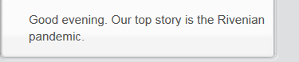

Good headline. Now summarize the story.

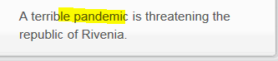

Keep your **to[ne o]f voice** more serious but don’t forget the drama. If this pandemic spreads the whole Europe, it would be a detrimental risk now. Describe what the pandemic is, what causes the pandemic, the symptom of the pandemic, and what happens so far.

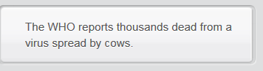

What is the EU doing about it?

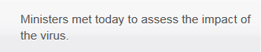

And what decision are ministers expecting to come to?

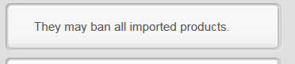

OK now from the pubic perspective, first of all, how can public identify the virus?

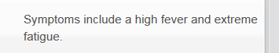

What should the public do when they show this symptoms?

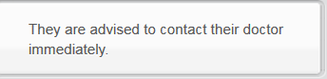

Alright. You ready? Countdown: 5, 4, 3, 2, 1. Action!

# Part 4 ) Write a news.

## 1st row

## Stop mp3: Lexical resource

* airlift something /ˈɛəˌlɪft/    
  1.N-COUNT An airlift is an operation to move people, troops, or goods by air, especially in a war or when land routes are closed. 空运 e.g. President Garcia has ordered an **airlift** of food, medicines and blankets. 加西亚总统已经下令**空运**食品、药品和毛毯。  
  2.V-T If people, troops, or goods **are airlifted** somewhere, they are carried by air, especially in a war or when land routes are closed. 空运 e.g. The injured **were airlifted** to a hospital in Dayton. 伤员被空运到代顿的一所医院。
* embark on   
  1. 登上船(或飞机、汽车等)，搭载(船只等): to embark on a ship for America 乘船去美国  
  2. 开始(工作)；着手，从事: He has already embarked on his new dictionary. 他已开始编他的新词典。to embark on a business career 开始经商
* **mishap** /ˈmɪshæp/ A mishap is an unfortunate but not very serious event that happens to someone. 小灾难 V.S. natural **calamity**
* **heartfelt** /ˈhɑːtˌfɛlt/ heartfelt is used to describe a deep or sincere feeling or wish. 衷心的; 真心真意的(感谢；慰问；哀悼；慰问； 道歉) **[ 衷心的感谢heartfelt gratitude; 衷心的道歉heartfelt apology; 衷心的慰问哀悼heartfelt condolences; 衷心的慰问: heartfelt sympathy ]** e.g. My **heartfelt sympathy** goes out to all the relatives. 我对所有的亲属表示**衷心的慰问**
* **抓住某人的注意 grab** sb.’s attention
* 对xxx有支配力/控制立 **[ have a strong gri[p o]n sth; tighten sb's grip on sth = increase the control of sth ];** e.g. China also **has a strong grip on** wind power. It produces nearly half of the world's wind turbines -- at a rate of about two every hour.  
  e.g. The government had closed down more than 100 media outlets in Turkey in recent months. China, which had the most journalists in jail/behind bars in 2015, dropped to second spot. There were 38 behind bars (who are imprisoned) in 2016. "**This, however, should not be interpreted to mean that** press freedom in China has improved in the past year," "**On the contrary/conversely**, China has cracked down/suppress on human rights and civil libertiess, such as **slapping a blanket ban on** HK news websites, banning original reports on the Internet, preventig journalists from traveling, and **tightened its gri[p o]n** 支配力/控制立 Hong Kong media," she added
* recount [ri'kaunt]   
  n. an additional (usually a second) count; especially of the votes in a close election  
  v. **recount sth to sb = narrate['næreit] to sb sth 向*sb*讲述/叙述一个事情/经历/故事** or give a detailed account of, narrate to sb**. [ recount/narrate an event 讲述/叙述一个事件 ]**  
   e.g. He recounted his amazing experiences in Seoul to the pupils = he narrated to the pupils his amazing experience in Seoul. 他**向*学生们*讲述**他的经历  
  v. count again. E.g. Don't complain! Recount your blessings! 你数说数说你的幸福吧
* narrate   ['n**æ**reit] , narration [**nə**'reiʃən]; narrative ['n**æ**rətɪv]  : narrator[næ'reitɚ]
  + **narrate**['n**æ**reit]:   
    1.V 讲述，叙述   
    **[ 向*sb*讲述/叙述一个事情/经历/故事narrate to sb. the story of xxx = recount sth to sb ] [ recount/narrate an event 讲述/叙述一个事件 ]**e.g. He **narrated to us** the story of the two men's armed robbery. 他**向我们讲述**了..的经过。  
    2.给…作解说：to narrate a film 给一部电影作解说
  + **narration** [n**ə**'reiʃən] n)   
    1. 讲述，叙述（一个故事）narration= **storytelling= narrative** ['nærətɪv]  : a message that tells the particulars of an act or occurrence or course of events; presented in writing or drama or cinema or as a radio or television program; synonym: storytelling  
    2. the act of giving an account describing incidents or a course of events (故事,事件的) 解说 e.g. his narration was hesitant  
    3. (rhetoric) the second section of an oration in which the facts are set forth
  + **narrative ['nærətɪv]**    
    N) **narrative = narration** [nə'reiʃən] 叙述讲述；讲故事: a message that tells the particulars of an act or occurrence or course of events; presented in writing or drama or cinema or as a radio or television program   
    adj. 叙事的，叙述的；叙事体的
  + narrator [n**æ**'reitɚ]   n. 叙述者；解说员

|  |  |
| --- | --- |
| e.g. The **narrative present** involves narrating a **past** event in the **present** tense. This technique brings immediacy [i'mi:d***iə***si] 直接性；即时性to a story, and helps the reader or listener visualize it better. The **narrative present** is often **used in novels;** for example: | |
|  | |
|  |  |

|  |  |
| --- | --- |
|  | It **was** a cold day in December. The room **was** dark and bare. I **realize** I am not alone. Jones **is sitting** on a chair in the shadows... |

* immediacy   [i'mi:d***iə***si] n直接性；即时性；紧急性刻不容缓

e.g. The difference is that buttons on a toolbar advertise their **immediacy**直接性 because they are known by convention to be imperative controls.   不同之处在于工具栏上的图标按钮说明了它们的直接性。 因为它们是按钮，所以工具栏是直接命令应该待的地方

* cleft sentence: 【语法学】分裂句,割接句 A cleft sentence is a complex sentence (one having a main clause and a dependent clause) that has a meaning that could be expressed by a simple sentence. Clefts typically put a particular constituent into focus. 【语法学】分裂句,割接句(用转换语法产生的句子,即在原句前加what,在原句后加be的一种形式,并在be后放原句的宾语。如: Children like ice-cream. 转换成分裂句为 **What** children like **is** ice-cream.)
* emigrate 移民移出V.S. immigrate 移民移入
  + emigrate /ˈɛmɪˌɡreɪt/; 移居外国 emigration:  If you emigrate, you leave your own country to live in another country. 移居外国 emigrate from your own country to another country   
    e.g. He emigrated to Belgium. 移民去了比利时。  
    e.g. When you emigrate from your country to Canada, you may find that people in Canada have trouble accepting you and it’s hard to **assimilate into the local community同化**
  + immigrate: If someone immigrates to a particular country, they come to live or work in that country, after leaving the country where they were born. 移居国外; 移民   
    e.g. He has been living in U.S. for 15 years. He immigrated from India at age 18. 他18岁时从印度移民出来
* axe /æks/ **[ sb. get the axe 被开除; have an axe to grind 另有所图；别有用心; (job, public welfare, TV shows, performance) be axed (工作, 公共服务，福利）被砍掉,9电视节目，演员的镜头）被砍掉 ]**

1. An axe is a tool used for cutting wood. It consists of a heavy metal **blade**刀刃 that is sharp at one edge and attached by its other edge to the end of a long handle. 斧子

2. V If **someone's job or something such as a public service, welfares, or a television programme or sb’s performance is axed**, it is ended **suddenly** and without discussion or beforehand notification. (工作, 公共服务，福利）被砍掉,(电视节目，某种服务）被砍掉 e.g. Community projects **are being axed** by hard-pressed social services departments. 社区项目正遭到受困社会服务部门的削减/**被砍掉** e.g. Finally, in the **spring gala 春晚**, his solo dancing **is axed.** 他的独舞节目**被砍掉了** e.g. Since two years ago, the only welfare in IBM, that is the gym card, **was axed** based on the **new austerity measures** because of plummeted/stumbled company revenue.... 唯一的福利也**被砍掉** e.g. **Slammed by** lower oil revenues, the Saudi Arabia's budget deficit swelled to 366 billion riyals [rɪ'jɑːl]. **In response,** the government has already **slashed/axed energy subsidies 砍掉**补贴 and cut wages for officials. But in a new report, it warns of **dire/terrible consequences** if it doesn't press ahead with more **austerity measures**[财政] 紧缩措施

* spot /spɒt/

1. Spots are small, round, coloured areas on a surface. 斑点 e.g. The leaves have yellow areas on the top and underneath are powdery orange **spots**. 橙色斑点。

2. **Spots on a person's skin** are small lumps or marks. (皮肤上的) 小疙瘩; 斑 My brother's face was covered with spots. 我弟弟曾满脸疙瘩。**//pimples斑点, burst-out, flecks雀斑; pockmarks痘疤**

3. You can refer to a particular place as a spot or site 地点 e.g. They stayed at several of the island's top tourist spots. 他们在岛上几个最好的旅游景点呆过。 e.g. Though no airport has been able to knock Changi from the top spot, there's been a bit of movement in the rest of the top 10. Tokyo International Airport jumped two spots to push South Korea's Incheon International Airport from last year's second place position, moving Seoul's gateway to third.

4. **A spot in a television or radio show** is a part of it that is **regularly reserved** for a particular performer or type of entertainment. **固定节目档**  e.g. He **got a spot on a CNN show**, which is 5-mins talk show for the breaking news 在CNN得到了一个固定节目档。

5. V-T If you spot something or someone, you notice them by eyes. (肉眼)发现xxx E.G. Vicenzo failed to **spot the error**. 维森佐没能发现这个错误。 E.g. Finally, after **scouring** the India ocean for 7 dats, searches finally **spot the debris(肉眼)发现** of MH370 fuselage机身 that **ditched (飞机) 紧急迫**降into ocean last week

6. N A spot of a liquid is a small amount of it. 滴; 点 **[雨点 spots of rain; 墨滴spots of ink]** e.g. **Spots of rain** had begun to fall. 雨点已经开始落下来了。

7. If you **do something on the spot**, you do it immediately. 当即; 当场就(被录用了，斩首了，逮捕了) e.g. James was called to see the producer and **got the job on the spot**. 当即得到了那份工作。E.g. After 3-hr **grueling** interview, Tracy **got the offer on the spot** from **the prestigious university**有声望的大学.

* double meanings
* punchy /ˈpʌntʃɪ/ (**punchier**,**punchiest**)  If you describe something as **punchy**, you mean that it expresses its meaning in a forceful or effective way. 强力的 **[ A short and punchy headline in a newpaper 简短有力的新闻标题]**   
  e.g. A good way to sound confident is to use **short and punchy sentences**. 是要把用强力的话说在点子上 e.g. LuXu, one of the most **influential** literates in China, use his **punchy writing** to deliver profound impact.

 （newspaper headline, shortdescription）简短有力

* punchline： The punchline of a **joke/knee-slapper** or funny story is its **last** sentence or phrase, which makes it funny. 笑话或警句令人发笑的最后一行
* A **pun** is a clever and amusing use of **a word or phrase with two meanings**, or of **words with the same sound but different meanings** (e.g. “whole” v.s. “hole”; weather V.S. whether). For example, if someone says "The peasants are revolting," this is a pun because it can be interpreted as meaning either that the peasants are fighting against authority, or that they are disgusting. 双关语
* bouncy castles **[ 充气城堡 the inflatable bouncy castle ]** e.g. The children were **frolicking嬉戏** on **the inflatable “bouncy castle**”. 在充气城堡上玩
* inflate, inflatable /ɪnˈfleɪtəbəl/ V.S. economic inflation, inflational  通货膨胀的；通货膨胀倾向的
  + inflate the balloon; inflate the airbag; inflate the life vest/jacket
  + inflatable /ɪnˈfleɪtəbəl/  **[ 充气城堡 the inflatable bouncy castle ]** An **inflatable object** is one that you fill with air when you want to use it. 可充气的   
    e.g. The children were **frolicking嬉戏** on **the inflatable “bouncy castle**”. 在充气城堡上  
    e.g. This **life vest/jacket救生衣** is **inflatable**. However, never **inflate it** when you’re still under the water.  
    e.g. 'Children's **inflatable equipment** labeled unsafe.'
  + N) An inflatable is an inflatable object, especially a small boat. 可充气物品 [...floats, life vest/jacket, balloons, tubes and other **inflatables**. …救生艇、轮胎和其他**可充气物品** ]
  + economic inflation, inflational 通货膨胀的；通货膨胀倾向的
* 红肿的; 发炎的inflamed /ɪnˈfleɪmd/  If part of your body is inflamed, it is red or swollen, usually as a result of an infection, injury, or illness. **[ inflamed throat; inflamed gum ]**  E.g. Symptoms include red, **itchy** and **inflamed skin**. 症状包括皮肤红肿、瘙痒和发炎
* 手工精酿/酿造的啤酒e.g. I like **craft beer** 我喜欢**手工酿造的啤酒**
* 1. (优质葡萄酒的) 生产年份和地点; (特定年份酿造的) 葡萄酒 2.老式的 (汽车或飞机) 3.老式而优质的 (衣物, 家具, 照片)

vintage /ˈvɪntɪdʒ/

1. **The vintage of a good quality wine** is the year and place that it was made before being stored to improve it. You can also use vintage to refer to the wine that was made in a certain year. (优质葡萄酒的) 生产年份和地点; (特定年份酿造的) 葡萄酒 e.g. This wine is from one of the two best vintages of the decade in this region. 是这一地区近十年来葡萄产量**最好的两个年份**之一生产的佳酿。

2. **Vintage wine** is good quality wine that has been stored for several years in order to improve its quality. 优质的 (葡萄酒) e.g. If you can buy only one case at auction, it should be **vintage port.** 就应该是**优质的波尔图葡萄酒**。

3. Vintage cars or airplanes are old but are admired because they are considered to be the best of their kind. **老式的 (汽车或飞机)** 古董 **[ vintage cars; vintage planes ]** e.g. The museum will have a permanent exhibition of 60 vintage and racing cars. 这家博物馆将永久展出60辆**老式汽车和赛车**。

4. **Vintage clothing, furniture, photo** is old or secondhand, but usually of good quality, sort of antiques( 古董**) 老式而优质的 (衣物, 家具, 照片)** e.g. ...collectors of **vintage clothing**.…古装收藏者 e.g. Thomas Ruff's **vintage photos** of forgotten Hollywood actresses

* vinery /ˈ**V**aɪnərɪ/ v.s winery['**w**ainəri]
  + **v**inery a hothouse for growing grapes 葡萄温室
  + **w**inery /ˈwaɪnərɪ/ A winery is a place where **wine** is made. 葡萄酒厂
  + brewery /ˈbrʊərɪ/ brew, brewy: A brewery is a place where **beer** is made. 啤酒厂

## Video: A **short punchy headline**强力的 in a new



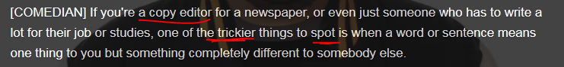



e.g. Here comes a confusing news headline 



 （newspaper headline, shortdescription）简短有力



Look at these examples:

*  e.g. “Inflatable children’s play equipment deemed unsafe” 



*  e.g. “**Rolling down** mountains, terrified villages see available.” This sentence indicates that the village can roll down..not human…
*  e.g. “Police help dog bite victim”



## Stop mp3: 2nd row confusing or ambiguous words

|  |  |
| --- | --- |
| **Confusing words** | |
|  | |
| Some words are frequently misused because they sound the same as another word, even though they are spelled differently and have a different meaning. They are called **homonyms**. Here are examples of two words frequently confused with a contraction. | |
|  | |
|  |  |

|  |  |
| --- | --- |
|  | ***Their*** *family is coming to town.* |
|  |  |

|  |  |
| --- | --- |
|  | ***They're*** *coming to town.* |
|  |  |
|  |  |

|  |  |
| --- | --- |
|  | *The country has* ***its*** *problems.* |
|  |  |

|  |  |
| --- | --- |
|  | ***It's*** *a country with problems.* |

|  |  |
| --- | --- |
| **Confusing words** | |
|  | |
| Some words are frequently misused because they sound the same as another word, even though they are spelled differently and have a different meaning. They are called **homonyms**. Here are examples of two words frequently confused with a contraction. | |
|  | |
|  |  |
|  | ***Their*** *family is coming to town.* |
|  |  |

|  |  |
| --- | --- |
|  | ***They're*** *coming to town.* |
|  |  |
|  |  |

|  |  |
| --- | --- |
|  | *The country has* ***its*** *problems.* |
|  |  |

|  |  |
| --- | --- |
|  | ***It's*** *a country with problems.* |

|  |  |
| --- | --- |
| Here are more words that are frequently confused with one another because they sound the same. | |
|  | |
|  |  |
|  | *The* ***whole*** *outfit is ruined because of this* ***hole****.* |
|  |  |

|  |  |
| --- | --- |
|  | *Do you know* ***whether*** *the* ***weather*** *forecast calls for rain?* |

|  |  |
| --- | --- |
| Here are examples of nouns frequently confused with a similar-sounding verb. In the sentences below, **effect** and **advice** are nouns and **affect** and **advise** are verbs. | |
|  | |
|  |  |

|  |  |
| --- | --- |
|  | *The housing market had a huge* ***effect*** *on the economy.* |
|  |  |

|  |  |
| --- | --- |
|  | *The housing market hugely* ***affects*** *the economy.* |
|  |  |
|  |  |

|  |  |
| --- | --- |
|  | *Their* ***advice*** *is to contact a doctor.* |
|  |  |

|  |  |
| --- | --- |
|  | *They* ***advise*** *you to contact a doctor.* |

|  |  |
| --- | --- |
| **Confusing words** | |
|  | |
| Some words are frequently misused because they sound the same as another word, even though they are spelled differently and have a different meaning. They are called **homonyms**. Here are examples of two words frequently confused with a contraction. | |
|  | |
|  |  |
|  | ***Their*** *family is coming to town.* |
|  |  |

|  |  |
| --- | --- |
|  | ***They're*** *coming to town.* |
|  |  |
|  |  |

|  |  |
| --- | --- |
|  | *The country has* ***its*** *problems.* |
|  |  |

|  |  |
| --- | --- |
|  | ***It's*** *a country with problems.* |

|  |  |
| --- | --- |
| Here are more words that are frequently confused with one another because they sound the same. | |
|  | |
|  |  |
|  | *The* ***whole*** *outfit is ruined because of this* ***hole****.* |
|  |  |

|  |  |
| --- | --- |
|  | *Do you know* ***whether*** *the* ***weather*** *forecast calls for rain?* |

|  |  |
| --- | --- |
| Here are examples of nouns frequently confused with a similar-sounding verb. In the sentences below, **effect** and **advice** are nouns and **affect** and **advise** are verbs. | |
|  | |
|  |  |
|  | *The housing market had a huge* ***effect*** *on the economy.* |
|  |  |

|  |  |
| --- | --- |
|  | *The housing market hugely* ***affects*** *the economy.* |
|  |  |
|  |  |

|  |  |
| --- | --- |
|  | *Their* ***advice*** *is to contact a doctor.* |
|  |  |

|  |  |
| --- | --- |
|  | *They* ***advise*** *you to contact a doctor.* |

|  |  |  |  |  |  |
| --- | --- | --- | --- | --- | --- |
| Here are more words that are frequently misused because they sound similar. Notice that **hard** and **hardly** are especially difficult because they are both adverbs. **Hard** means that he is putting in a lot of effort. **Hardly** means **little** or **barely**. | | | | | |
|  |  |  | | |  |
|  |  |  | | |  |
|  | *This is such a* ***special*** *day,* ***especially*** *because your grandmother was able to join us.* | |  | This is such a special day, especially because your grandmother was able to join us. | |
|  |  | |  |  | |

|  |  |  |  |
| --- | --- | --- | --- |
|  | *Is he working* ***hard*** *or* ***hardly*** *working?* |  | Is he working hard or hardly working? |
|  |  |  |  |

|  |  |  |  |
| --- | --- | --- | --- |
|  | ***Except*** *for Tanya, the family couldn't* ***accept*** *the news.* |  | Except for Tanya, the family couldn't accept the news. |
|  |  |  |  |

|  |  |  |  |
| --- | --- | --- | --- |
|  | *The* ***emigrant*** *left his country and entered the US as an* ***immigrant****.* |  | The emigrant left his country and entered the US as an immigrant. |

## 3rd row: cleft sentence

Cleft sentence: A cleft sentence is a complex sentence (one having a main clause and a dependent clause) that has a meaning that could be expressed by a simple sentence. Clefts typically put a particular constituent into focus. 【语法学】分裂句,割接句(用转换语法产生的句子,即在原句前加what,在原句后加be的一种形式,并在be后放原句的宾语。如: Children like ice-cream. 转换成分裂句为 What children like is ice-cream.)

|  |  |
| --- | --- |
| **Reordering sentences for emphasis** | |
|  | |
| Sometimes speakers and writers want to focus attention on a particular thing or idea. One way to do that is to change the order of a sentence. In some grammar books, this is referred to as a **cleft sentence** (cleft sentence). Here are some examples: | |
|  | |
| **Starting a sentence with 'It'** | |
|  | |
| The simplest way to reorder a sentence for emphasis is to begin with **It + be** and the noun you want to emphasize. Then, connect the remainder of the sentence with a relative pronoun like **who** or **that**. Notice how **Paul** and **a piece of cake** are emphasized in the following sentences. | |
|  | |
|  |  |

|  |  |
| --- | --- |
|  | *Paul stole the diamond rings.* |
|  |  |

|  |  |
| --- | --- |
|  | ***It was Paul who*** *stole the diamond rings****.*** |
|  |  |

|  |  |
| --- | --- |
|  | *He wanted a piece of cake.* |
|  |  |

|  |  |
| --- | --- |
|  | ***It was a piece of cake that*** *he wanted.* |

|  |  |
| --- | --- |
| **Starting a sentence with 'There'** | |
|  | |
| **There + be** can also be used to emphasize sentences beginning with a noun, rather than a pronoun. Notice the change in the article, from **the** to **a** or **an**. | |
|  | |
|  |  |

|  |  |
| --- | --- |
|  | *The man had a gun.* |
|  |  |

|  |  |
| --- | --- |
|  | ***There was a man who*** *had a gun.* |
|  |  |

|  |  |
| --- | --- |
|  | *The idea was good.* |
|  |  |

|  |  |
| --- | --- |
|  | ***There was an idea that*** *was good.* |

|  |  |
| --- | --- |
| **Starting a sentence with 'What' or 'All'** | |
|  | |
| You can also emphasize with **What** or **All** and connect the remainder of the sentence with **be**. Notice how the sentences with **What** keep the same meaning but change the emphasis; the sentences with **All** change the emphasis and change the meaning slightly. **All** is similar in meaning to **only** in these sentences. | |
|  | |
|  |  |

|  |  |
| --- | --- |
|  | *I wanted to say 'thank you.'* |
|  |  |

|  |  |
| --- | --- |
|  | ***What I wanted to say was*** *'thank you.'* |
|  |  |

|  |  |
| --- | --- |
|  | ***All I wanted to say was*** *'thank you.' (I only wanted to say 'thank you'.)* |
|  |  |
| Here's another example. | |
|  |  |
|  |  |

|  |  |
| --- | --- |
|  | *The woman had a dog.* |
|  |  |

|  |  |
| --- | --- |
|  | ***What the woman had was*** *a dog.* |
|  |  |

|  |  |
| --- | --- |
|  | ***All the woman had******was*** *a dog. (She only had a dog.)* |

|  |  |
| --- | --- |
| **Using 'If' and 'it was because'** | |
|  | |
| Notice in this example the heavy stress on the words **stole** and **cold**. Notice also that **if** here does not communicate a condition. Instead, it helps **it was because** emphasize the last part of the sentence. | |
|  | |
|  |  |

|  |  |
| --- | --- |
|  | *He* ***stole*** *the blanket because he was* ***cold****.* |
|  |  |

|  |  |
| --- | --- |
|  | ***If*** *he* ***stole*** *the blanket****, it was because*** *he was cold.* |

## Examples of “cleft sentences”

 【语法学】分裂句,割接句(用转换语法产生的句子,即在原句前加what,在原句后加be的一种形式,并在be后放原句的宾语。如: Children like ice-cream. 转换成分裂句为 **What** children like **is** ice-cream.)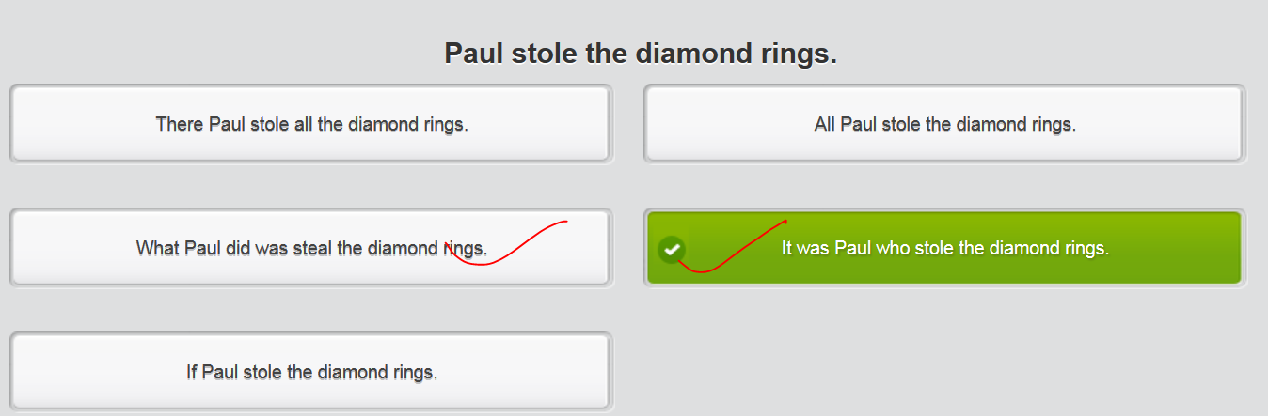

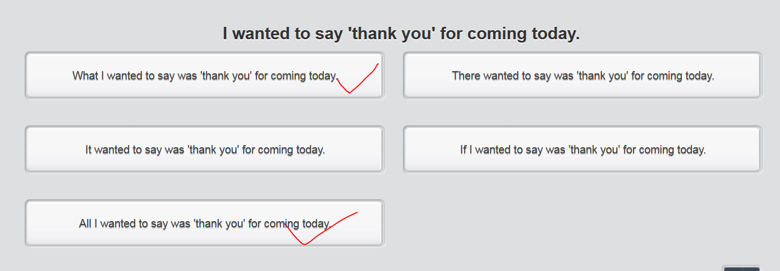

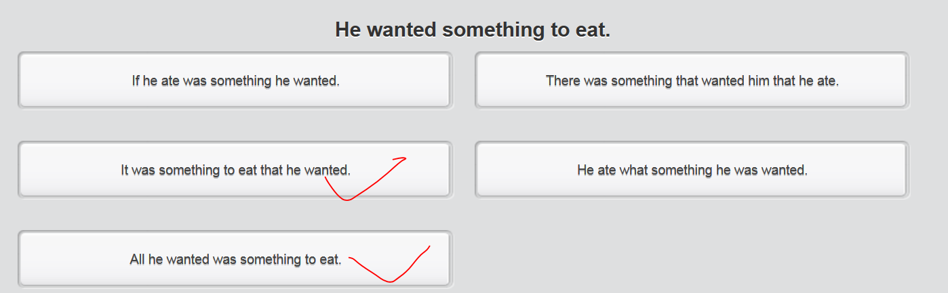

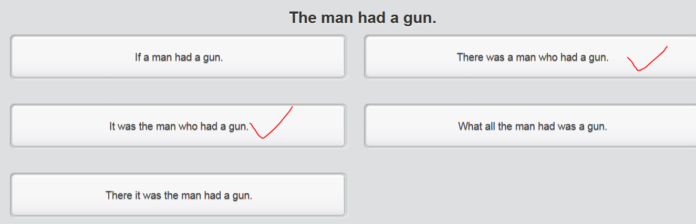

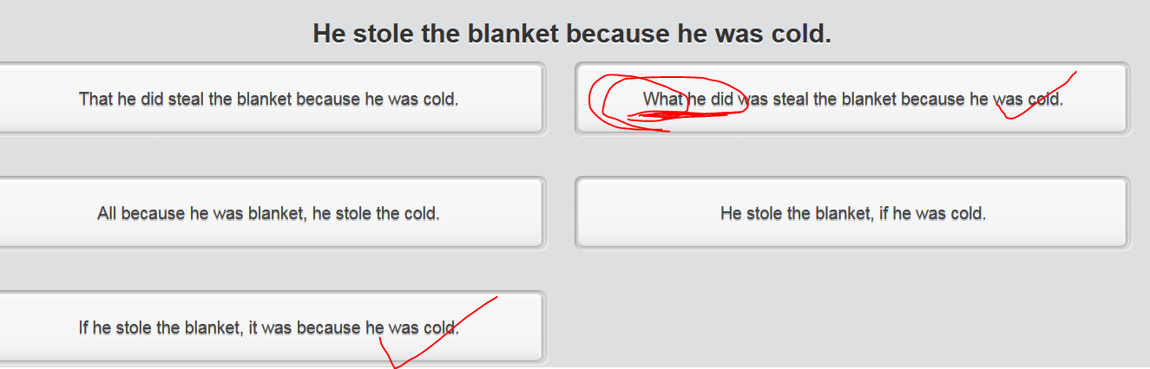

## Stopmp3



## Stop mp3: 4th row **Narrative Present**

* immediacy   [i'mi:diəsi] n直接性；即时性；紧急性刻不容缓

|  |  |
| --- | --- |
| The **narrative present** involves narrating a **past** event in the **present** tense. This technique brings immediacy [i'mi:d***iə***si] 直接性；即时性to a story, and helps the reader or listener visualize it better. The **narrative present** is often **used in novels;** for example: | |
|  | |
|  |  |

|  |  |
| --- | --- |
|  | It **was** a cold day in December. The room **was** dark and bare. I **realize** I am not alone. Jones **is sitting** on a chair in the shadows... |
|  | |
| Notice how switching **from the past tense to the present** heightens the effect of the narrator’s surprise. The **narrative present** is also often **used in informal, oral storytelling**; for example: | |
|  | |
|  |  |

|  |  |  |
| --- | --- | --- |
|  | 'So, John **sees** Mary at the party and immediately **turns around** and **walks** right out! We couldn't believe it!' | |
|  | | |
| Again, this helps the listener imagine the situation, and heightens the **dramatic effect** of the narrative. | | |
| The **narrative present** is, however, **not usually used in official accounts or formal reports**, such as a police report. For example: | | |
|  | | |
|  | |  |

|  |  |
| --- | --- |
|  | The suspect **was seen** leaving the scene of the crime at 10.30 pm last night. He **was arrested** two hours later. |
|  | |
| **In official reports**, clarity, as opposed to immediacy [i'mi:d***iə***si] n直接性；即时性, is the objective, so **past tense**s are almost always used to describe **past events**. | |

## Stop mp3: Recount an event 讲述/叙述一个事件

v. **recount sth to sb = narrate['næreit] to sb sth 向*sb*讲述什么事情/经历/故事** or give a detailed account of, narrate to sb. **[ recount/narrate an event 讲述/叙述一个事件 ]** e.g. He recounted his amazing experiences in Seoul to the pupils = he narrated to the pupils his amazing experience in Seoul. 他**向*学生们*讲述**他的经历

e.g. A woman was **recounting an event** to polices.

At 6:45 am, the police received a phone call from a woman who was screaming **hysterically** 歇斯底里地. They could not understand what she was saying so they asked her to calm down. The woman, who seemed to be in her late 50s, stopped screaming and spoke in a calm voice. She told the policeman that her little three-month-old black and white cat had jumped from her balcony on the third floor and was now stuck in a tree outside her window. The patient policeman was telling the now somewhat calmer lady not to worry; he would send a team to rescue the cat. The woman was reassured. Finally, she told the policeman that it was important for them to know that it was the tall fir tree outside her bedroom window the cat was sitting in, not the pine tree outside her balcony.

## 5th row Writing a news/story

Think of a story that has recently been in the news. Write your own report of the story.

|  |
| --- |
| Narrative structure  1. Introduction 2. Rising action 3. Climax 4. Falling action 5. resolution **(决心；决议；解决方法)** |

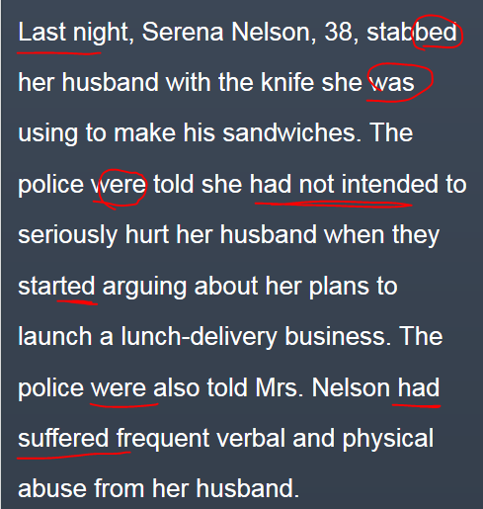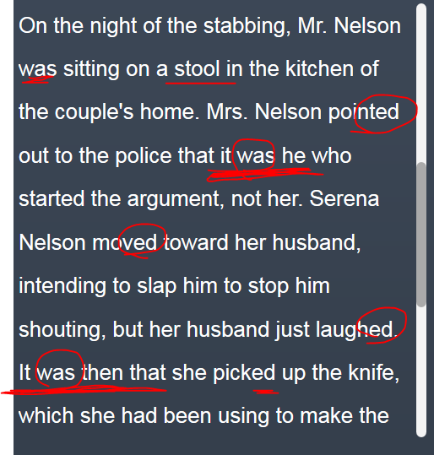 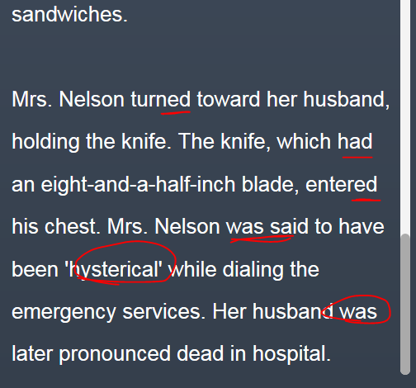

## my writing

* Story introduction:   
  I read a sort of outrageous news from CNN that a passenger David’s pet, a puppy, was mistakenly delivered to another city during a 4-hour **layover** by American airline. It was the American airline again that committed another **wrongdoing** after the rather **notorious** scandal of **yanking猛的拉** the so-called “**belligerent好战的**[bi'lidʒərənt]” passenger from the plane.
* Rising action:

It’s reported that David had clearly added some notification on the **luggage manifest** that he pleased airline deliverers to carefully take care of his young puppy. David said that he had reiterated his request for many times during check-in and layover, in order to make sure that his puppy is in safe situation. However, the **mishap** /ˈmɪshæp/ still happened unexpectedly.

Climax:   
As soon as David got the bad information from a **flight attendant** when he **embarked on** another short-haul plane **after layover**, he was so irritated. He didn’t want to waste time in nee quickly contacted the emergency officials to deal with this accident. On the side of airline, in response, the airline sincerely acknowledged the **oversight**疏忽 and sent their “heartfelt” apology to David who was obviously annoyed by their carelessness and refused to accept any apology. In addition, David also expressed his strong dissatisfaction on Twitter with **harsh and barbed words** that sarcastically criticized the airline who never learnt painful lessons from their previous disgusting events.

* Falling action:

Resolution:   
After a hard negotiation with airline officials, finally, David’s puppy was **airlifted** to the correct city. Surprisingly, even though the puppy had been enjoying his super long-haul trip for more than 20 hours, he was still energetic, of course, in good health situation, upon which, David got a total relief.

# ** CNN related news or podcast about “news”

## Liu, the noble price winner died in prison

<http://edition.cnn.com/2017/07/13/asia/liu-xiaobo-death-china/index.html>

The Chinese government is facing mounting international

criticism for its treatment of Nobel Peace Prize-winning human rights campaigner Liu Xiaobo, who died while in custody at age 61, Thursday.

Liu, who spent more than a decade behind bars in China for his advocacy of political reform, including taking part in the bloody 1989 [Tiananmen Square protests](http://www.cnn.com/2013/09/15/world/asia/tiananmen-square-fast-facts/index.html), had been serving a 11-year prison term for "inciting subversion of state power," when he was diagnosed with late stage liver cancer in May this year.

The Chinese government had refused to let him seek treatment overseas despite Liu's wishes and international pressure. His death, of multiple organ failure, makes Liu the first Nobel Peace laureate to die in custody since Carl von Ossietzky in Nazi Germany in 1938.

Berit Reiss-Andersen, the chair of the Norwegian Nobel Committee -- which awards the Nobel Peace Prize -- said the Chinese government "bears a heavy responsibility for his premature death."

In [a statement](https://www.facebook.com/nobelprize/posts/10154770205089103) released Thursday, she said Liu Xiaobo was a representative of "ideas that resonate with millions of people all over the world, even in China. These ideas cannot be imprisoned and will never die."

In October 2010, while serving his sentence at Jinzhou Prison, near Shenyang, Liu was named the winner of the Nobel Peace Prize for "his long and non-violent struggle for fundamental human rights in China."

Liu's absence from the Nobel ceremony was marked by an empty chair.

"We now have to come to terms with the fact that his chair will forever remain empty," Reiss-Andersen said.

"At the same time it is our deep conviction that Liu Xiaobo will remain a powerful symbol for all who fight for freedom, democracy and a better world."

Messages of solidarity and sadness

World leaders and rights campaigners were quick to react to the news of Liu's death with messages of grief and sharp condemnation.

The White House called Liu a "political prisoner," and offered "heartfelt condolences go out to Liu Xiaobo's wife, Liu Xia, and his family and friends."

Liu was first jailed for his role in the 1989 pro-democracy movement after the bloody crackdown in Beijing's Tiananmen Square -- and later for petitioning for political reform and co-writing a paper on policy toward Taiwan that was at odds with the government stance.

His most recent conviction, in December 2009, stemmed from his co-authorship of Charter 08, a manifesto calling for political reform and human rights in China.

Taiwanese President Tsai Ing-wen, one of the few political leaders to openly call for Liu's freedom throughout her time in office, called on China tohelp realize Liu's "Chinese dream" by implementing political reforms and allowing citizens "the natural right to democratic freedom."

The leader of the self-ruled island regarded by Beijing as a renegade province wrote that Liu "has no enemies, because democracy has no enemies."

Democracy advocates in Hong Kong, where Liu's activism continues to resonate strongly, vowed to "continue our fearless non-violent protests."

A protester cries as she mourns Liu Xiaobo during a demonstration outside the Chinese liaison office in Hong Kong, Thursday, July 13.

"In memory of the selfless struggle of Mr Liu, Demosisto will strive to carry forward his legacy," [said Hong Kong political party Demosisto](https://www.facebook.com/demosisto/photos/a.497270963815064.1073741828.495193710689456/710267455848746/?type=3&theater), which counts pro-democracy activist Joshua Wong and lawmaker Nathan Law among its members[.](https://www.facebook.com/demosisto/photos/a.497270963815064.1073741828.495193710689456/710267455848746/?type=3&theater)

A spokesperson for the German chancellor, Angela Merkel, paid tribute to "a brave fighter for civil rights and freedom of expression."

In a statement, US Secretary of State Rex Tillerson said Liu "dedicated his life to the betterment of his country and humankind, and to the pursuit of justice and liberty," and urged Chinese authorities to release Liu's wife from house arrest and allow her to travel outside China.

Liu's wife, Liu Xia -- an artist and a poet -- has been under house arrest since Liu's Nobel victory.

With her communication with the outside world almost completely cut off by the government, Liu Xia has been suffering severe depression, according to friends, especially after authorities sentenced her brother to 11 years in prison over what supporters call trumped-up charges of business fraud.

The UN High Commissioner for Human Rights Zeid Ra'ad Al Hussein echoed calls for her release, asking that the Chinese authorities give her the right to travel.

"Liu Xiaobo was the true embodiment of the democratic, non-violent ideals he so ardently advocated," Zeid said. "Despite the imprisonment and separation from the wife he adored that could have (fueled) anger and bitterness, Liu Xiaobo declared that he had no hatred for those who pursued and prosecuted him.

In the Chinese government's first official statement, Foreign Ministry spokesman Geng Shuang said authorities "made all-out efforts to treat him out of humanity and in accordance with law" after Liu was diagnosed with liver cancer.

Geng said Liu was convicted of violating Chinese law and criticism of China's handling of the case was an "improper" intrusion into the country's domestic affairs.

Many of Liu's friends and supporters took to social media to contest the government stance.

Chinese [activist Chen Guangcheng](http://cnn.com/2012/05/19/world/asia/china-us-chen/index.html), who sought political asylum at the US embassy in Beijing in 2012 after escaping from house arrest, wrote on Twitter: "By torturing and killing Liu Xiaobo, the Chinese Communist authorities have blocked all possibilities of progress." Chen is the author of "The Barefoot Lawyer: A Blind Man's Fight for Justice and Freedom in China."

Chinese human rights lawyer and scholar Teng Biao, who fled the country in 2014, tweeted:"(Liu Xiaobo) has died. His love, courage and strength will never die.'

Ai Weiwei, another Chinese dissident and perhaps the country's most famous living artist, tweeted: "Liu Xiaobo is gone - rest in peace. We are here, with Xiaobo."

Some of the sharpest condemnation of the Chinese government came from Human Rights Watch. The "government's arrogance, cruelty, and callousness are shocking -- but Liu's struggle for a rights-respecting, democratic China will live on," said the organization's China director Sophie Richardson.

Liu Xiaobo, a brave champion of nonviolence, human rights, and freedom, will be remembered/imprinted. in China and throughout the world. [pic.twitter.com/Dff32gHhtH](https://t.co/Dff32gHhtH)

Salil Shetty, secretary-general of Amnesty International, called Liu "a man of fierce intellect, principle, wit and above all humanity."

"Despite enduring years of persecution, suppression and imprisonment, Liu Xiaobo continued to fight for his convictions," Shetty said.

## “Craft wine” 手工精酿/酿造的啤酒

<http://money.cnn.com/2017/07/13/smallbusiness/wine-retail-millennial/index.html>

vinery /ˈVaɪnərɪ/ v.s winery['wainəri]

o **v**inery a hothouse for growing grapes 葡萄温室

o winery /ˈwaɪnərɪ/ A winery is a place where **wine** is made. 葡萄酒厂

o brewery /ˈbrʊərɪ/ brew, brewy: A brewery is a place where **beer** is made. 啤酒厂

These companies want to help you discover (and afford) **craft wine.** **Boutique** **wineries葡萄酒厂** across the country are producing small batches of everything from pinot noir to chardonnay, but it can be difficult for us twenty-somethings to find -- let alone afford -- those wines.

Your go-to vino is likely made by one of three major producers that account for over half of the U.S. wine market, [according to a 2016 Michigan State University study](https://msu.edu/%7Ehowardp/wine.html). Plus, many boutique wineries make less than 1,000 cases per year and sell mainly through pricey wine clubs, making them hard to access.

Online platforms like Winestyr and Glassful are trying to change that.

**How wine platforms work**

Winestyr gives boutique producers an opportunity to reach shoppers across the nation. The platform, which focuses on small-batch wines, sells individual bottles for around $25. It also offers curated monthly subscription boxes.

[Related: A long-shot bet on craft beer is paying off for these investors](http://money.cnn.com/2017/04/10/smallbusiness/beer-investment-brewdog/index.html?iid=EL)

Gros Ventre Cellars, a boutique California winery run by husband and wife team Chris and Sarah Pittenger, uses Winestyr in hopes of growing its customer base.

"When you're a small winery like ours and don't have a tasting room ... you're always looking for creative ways to get your name and your brand out there and get introduced to new customers," Chris said.

Glassful is also trying to give small producers exposure. The site was acquired last year by Good Company Wines, which owns another online retailer called Invino.

While Invino is geared toward baby boomers, Good Company Wines targets a younger audience with Glassful by re-marketing its Invino stock.

"What that does is it forces really high quality wines into this younger more Millennial audience," says Daniel Zinke, operations chief at Invino. "Normally they go to Whole Foods and grab the most exciting looking labels on the shelf. Glassful forces them to try these interesting wines."

**Why boutique wineries benefit**

Brooks Friedeman, who runs Friedeman wines with his wife Jessica, says he's noticed sales increase through Winestyr.

"We do about $2 to $3 a bottle better selling through Winestyr than we do selling through 3-tier wholesale distributors, and we're doing the same amount of work," Friedeman said.

Alcohol in the U.S. is traditionally sold through a 3-tier system. Producers like Friedeman represent the first tier. They sell their wines to wholesalers, who then sell to liquor stores and other retailers.

This system can be expensive for small producers. They pay a price at each stage of the process, regardless of whether consumers end up purchasing their wines. Winestyr instead operates on commission, while Glassful purchases bottles from wineries and sells directly to consumers.

[Related: Will banana wine catch on in America?](http://money.cnn.com/2016/12/15/smallbusiness/banana-wine-rwanda/index.html?iid=EL)

Winestyr and Glassful handle the bulk of the logistics, from packaging to shipping. But Winestyr requires producers to secure their own alcohol distribution licenses, which can vary by state. So you might not be able to buy certain wines from that platform depending on where you live.

These services can take a weight off small producers, many of which operate on a shoestring budget.

"We do all the work," says Winestyr CEO Bob Wilson.

**The downside for business**

Still, these sites aren't necessarily a silver bullet for wineries.

Shoppers who buy wine on platforms like Winestyr rarely go to the individual wineries' websites to sign up for their independent wine clubs, which is how most wineries make money.

It can be challenging for producers to secure repeat customers, particularly because twenty-somethings are less dedicated wine shoppers than their parents, says Glassful CEO Danielle Westfall.

[Related: South Africa's wine industry is booming](http://money.cnn.com/2016/02/23/news/economy/south-africa-wine/index.html?iid=EL)

It's nevertheless important for small producers to engage with younger shoppers.

"If you're a winery that wants to be in business two years form now, you should be getting Millennials interested in you," says wine industry consultant Dawn Dolan. .

They might not be wine loyalists yet, but for boutique wineries, every customer counts.

## Thomas Ruff's **vintage photos** of forgotten Hollywood actresses

<http://edition.cnn.com/2017/07/05/arts/thomas-ruff-photography/index.html>

Thomas Ruff is a photographer with an instantly recognizable style, one which you can see referenced in fashion magazines, galleries and Tumblr accounts the world over. His famous "Portraits" series, which he began in the '80s, has become an important touchstone for modern photography, with it's harsh, almost institutional style.

The series -- in which Ruff depicted his bohemian Dusseldorf circle in a vacant style -- was born in divided, paranoid, pre-unification Germany he grew up in. The images were a long way from the glossy photography of the era, and look as if they might have been pulled from a Stasi surveillance database. For Ruff, the theme of totalitarianism fed into both his work and daily life.

## China is crushing the U.S. in renewable energy

http://money.cnn.com/2017/07/18/technology/china-us-clean-energy-solar-farm/index.html

This solar farm floats atop a flooded coal mine. China may be the planet's biggest polluter but it's also powering ahead of other countries on **renewable energy.** As the Trump administration **yanks猛的一拉 the U.S. out of** the Paris climate change agreement, claiming it will hurt the American economy, Beijing isinvesting hundreds of billions of dollars and creating millions of jobs in clean power.

China has built vast solar and wind farms, helping fuel the growth of major industries that sell their products around the world. "Even in China where coal is -- or was -- king, the government still recognizes that the economic opportunities of the future are going to be in clean energy," said Alvin Lin, Beijing-based climate and energy policy director with the Natural Resources Defense Council.

More than 2.5 million people work in the solar power sector alone in China, [compared with 260,000 people](http://money.cnn.com/2017/05/24/news/economy/solar-jobs-us-coal/index.html?iid=EL) in the U.S., according to the most recent annual report from the International Renewable Energy Agency.

While President Trump promises to put American coal miners back to work, China is moving in the opposite direction. Coal still makes up the largest part of China's energy consumption, but Beijing has been shutting coal minesand set out plans last year to cut [roughly 1.3 million jobs](http://money.cnn.com/2016/02/29/news/economy/china-steel-coal-jobs/index.html?iid=EL) in the industry. The Chinese government has also moved to restrict the construction of new coal power plants.

For the first time ever, China's National Energy Administration in January established a mandatory target to reduce coal energy consumption. It also set a goal for clean energy to meet 20% of China's energy needs by 2030.

Analysts expect China to easily meet that target. Greenpeace noted in a [report](http://www.greenpeace.org/eastasia/press/releases/climate-energy/2017/By-2030-Chinas-wind-and-solar-industry-could-replace-fossil-energy-sources-to-the-tune-of-300-million-tonnes-of-standard-coal-per-year/) earlier this year that the country's clean energy consumption rose to 12% at the end of 2015. **Renewable energy** sources account for about [10% of total U.S. energy consumption](https://www.eia.gov/tools/faqs/faq.php?id=92&t=4), according to official statistics.

To help reach the 2030 goal, China is betting big on **renewable energy**. It pledged in Januaryto invest 2.5 trillion yuan ($367 billion) in renewable power generation -- solar, wind, **hydropower水利发电** and **biomass**, nuclear -- by 2020.

The investment will create about 10 million jobs in the sector, the National Energy Administration projects. China currently boasts 3.5 million jobs in clean energy, by far the most in the world, according to the International Renewable Energy Agency.

The country has already become a major manufacturer and exporter of renewable energy technology, supplying some two-thirds of the world's solar panels. China also **has a strong grip**支配 **on** wind power. It produces nearly half of the world's wind turbines -- at a rate of about two every hour.

China's hottest new project is a giant floating solar energy farm located in the eastern province of Anhui. Covering about 100 square miles, it is the largest floating panel facility in the world. It has the capacity to produce enough energy to power 15,000 homes, according to Sungrow Power Supply, the company behind the farm. Fittingly, the solar farm floats atop a flooded area once home to a coal mining factory.

The idea to float solar panels is fast catching on in an industry that faces one persistent problem -- space. Initially it is more expensive to build solar farms on water than on the land.But experts say floating solar panels can run more efficiently in the long run, because they are cooled by the water underneath.

"The whole world, including China, is recognizing that we need to fight climate change," said Yao. "I'm pretty sure this is going to be a trend." China's growing **dominance** in the sector has had a huge effect on the global market.

Manufacturers dramatically **ramped u**p production of solar panels, driven by an estimated $42 billion in government **subsidized** loans between 2010 and 2012, according to the GW Solar Institute at George Washington University. The flood of Chinese panels was one of the main reasons why [world prices crashed by 80%](http://www.irena.org/rethinking/Rethinking_FullReport_web.pdf) between 2008 and 2013.

The U.S. accused China of flooding the market and the Commerce Department started **imposing steep tariffs on** Chinese-made solar panels in 2012 in a bid to protect American producers.

Just last month, the U.S. informed the World Trade Organization that it may **impose tariffs on** imports of solar panels from other countries as well, alleging that Chinese companies have opened production facilities in third countries to get around import restrictions.